COMPUTER ARCHITECTUTRTE
CSA1214 CO3-AT1
K.Tharunika(192525276)
1.Design and simulate a system that performs register transfer operations along with basic arithmetic and logic operations such as addition, subtraction, AND, and OR. Use multiple registers to demonstrate how data is transferred between them during execution, and analyze the sequence of operations and the role of the ALU in processing data.
Anwser :
System Objective
The system performs:
- Register transfer: R1 → R2
- Addition: R3 ← R1 + R2
- Subtraction: R3 ← R1 − R2
- AND: R3 ← R1 AND R2
- OR: R3 ← R1 OR R2
- The system demonstrates register transfer and basic ALU operations using multiple registers.
- R1 and R2 store the input data.
- R4 demonstrates data transfer, such as R4 ← R1.
- The ALU performs arithmetic and logical operations:
- Addition: R3 ← R1 + R2
- Subtraction: R3 ← R1 − R2
- AND: R3 ← R1 AND R2
- OR: R3 ← R1 OR R2
- The Control Unit selects which operation the ALU should perform.
- The result is stored in R3.
- Example: If R1 = 25 and R2 = 10:
- ADD = 35
- SUB = 15
- AND = 8
- OR = 27
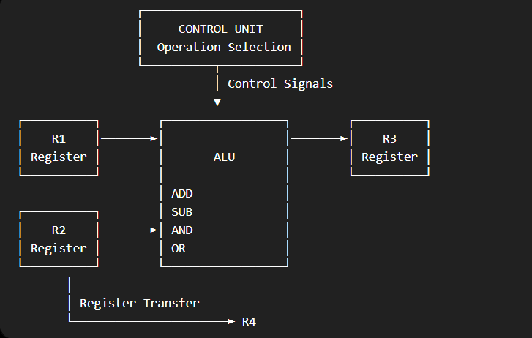
The ALU (Arithmetic Logic Unit) performs the arithmetic and logical operations, while the registers temporarily store the operands and results.

2. Create a model of a computer system using single-bus and multi-bus organization, and perform data transfer operations between registers, memory, and I/O. Compare the time taken and efficiency of both approaches, and analyse how multiple bus structures improve parallel data transfer and reduce bottlenecks.
Anwser:
The system models data transfer between the CPU registers, memory, and I/O devices using two approaches: single-bus and multi-bus organization.
1. Single-Bus Organization
In a single-bus system, all components share one common bus.
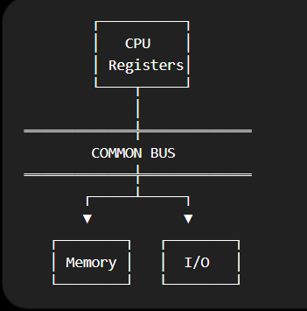
Only one major transfer can use the bus at a time.
Example:
R1 → Memory Memory → R2 R2 → I/O
These operations occur sequentially, which can create a bottleneck.

2. Multi-Bus Organization
A multi-bus system uses two or more buses, allowing multiple transfers to occur simultaneously.

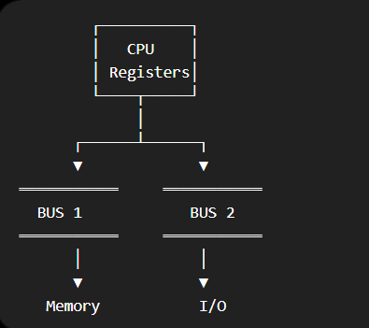
For example:
BUS 1: R1 → Memory
BUS 2: R2 → I/O
Both transfers can occur in parallel, depending on the hardware and control logic.
Single bus:
R1 → Memory = 1 cycle
Memory → R2 = 1 cycle
R2 → I/O = 1 cycle
Total = 3 cycles

Multi-bus:
BUS 1: R1 → Memory ──┐
── 1 cycle
BUS 2: R2 → I/O ──┘
Then: Memory → R2 = 1 cycle
Total = 2 cycles
A single-bus organization is simple and inexpensive but suffers from bus contention because components share the same communication path. A multi-bus organization provides multiple communication paths, allowing parallel data transfers, reducing bottlenecks, and improving overall system performance.
3.Simulate a 5-stage instruction pipeline (Fetch, Decode, Execute, Memory, Write-back) and execute a set of instructions. Measure the performance in terms of speedup and throughput, and compare it with a non-pipelined system to evaluate the effectiveness of pipelining. •
Anwser:
5-stage instruction pipeline divides instruction execution into five stages:
- IF – Fetch: Fetch the instruction from memory.
- ID – Decode: Decode the instruction and identify operands.
- EX – Execute: ALU performs the required operation.
- MEM – Memory: Access memory if required.
- WB – Write-back: Store the result in the destination register.

Simple Pipeline Diagram

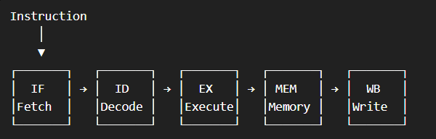
Pipelining improves processor performance by overlapping the execution of multiple instructions. Although the first instruction still takes five stages, subsequent instructions can use different stages simultaneously. Therefore, pipelining provides higher throughput and speedup compared with a non-pipelined processor.
4.Develop a pipeline execution scenario where data hazards, control hazards, and structural hazards occur. Observe their impact on instruction execution, and implement techniques such as stalling, data forwarding, and branch prediction to resolve these hazards and improve performance

Anwser:
- IF (Fetch): The instruction is fetched from memory.
- ID (Decode): The instruction is decoded and the required operands are identified.
- EX (Execute): The ALU performs the required operation.
- MEM (Memory): Memory is accessed if required.
- WB (Write Back): The final result is stored in the destination register.
I1: IF → ID → EX → MEM → WB
I2: IF → ID → EX → MEM → WB
I3: IF → ID → EX → MEM → WB
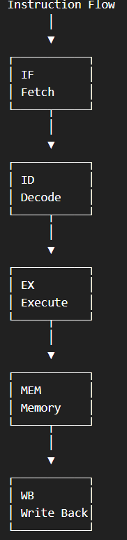
The important feature is overlapping. For example, while instruction I1 is in the Execute stage, I2 can be in Decode and I3 can be in Fetch.
Pipelining improves processor performance by allowing multiple instructions to be processed at the same time in different stages. While one instruction is being executed, another can be decoded and another can be fetched.
Thus, pipelining reduces the overall execution time, increases throughput, and provides better performance than a non-pipelined system.

5.Analyse a processor supporting superscalar execution, including out-of-order and speculative execution, and extend the study to include hyper-threading and simultaneous multithreading (SMT). Evaluate how multiple instructions are executed in parallel and compare the performance improvements in terms of instruction throughput and resource utilization.
Answer:
A superscalar processor can execute more than one instruction in a single clock cycle by using multiple execution units.
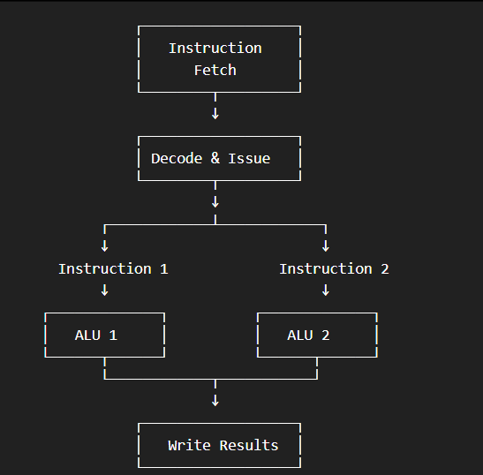.
- Superscalar execution: Multiple instructions are issued and executed simultaneously using different functional units.
- Out-of-order execution: Instructions that are ready can execute before earlier instructions that are waiting for data.
- Speculative execution: The processor predicts which instructions will be needed and executes them before the actual decision is known.
- Hyper-threading / SMT: Two or more instruction streams share the processor's execution resources, keeping unused resources busy.
Superscalar execution increases instruction throughput by executing multiple instructions in parallel. Out-of-order execution reduces delays caused by dependencies, while speculative execution keeps the processor busy by predicting future instructions. SMT/Hyper-threading improves resource utilization by allowing multiple threads to share processor resources. Together, these techniques can significantly improve processor performance compared with a basic single-issue processor.

